# Introduction

There is an identified need for cost-effective analog joysticks that can be used with the Xbox Adaptive Controller (XAC). There are currently not very many commercial joysticks on the market, and the ones that are can be costly. This joystick is intended to be used with the XAC for anyone who may find it easier to game with a joystick.

There is also a need for alternative mouse options that are affordable, and some people may find a joystick easier to use than a mouse. This mouse needs to be a standalone device that can be used with PC and can complete the basic mouse functions such as left click.

This joystick specifically is meant for someone with a lower range of motion and lower force compared to some USB joysticks.

# Research

## Commercial Joysticks:

|  |  |  |  |  |  |  |
| --- | --- | --- | --- | --- | --- | --- |
| Name | Price | | Link | | | Picture |
| Ultra-Stik | 95 UK | | [Accessible Gaming Shop - Ultra-Stik - OneSwitch.org.uk](https://www.oneswitch.org.uk/art.php?id=17) | | |  |
| XAC MINI Stick | 105 UK | | [XAC Mini Joystick - OneSwitch.org.uk](https://www.oneswitch.org.uk/art.php?id=270) | | |  |
| Optima Joystick | 219.60 UK | | [Optima Joystick - Video Gaming Assistive Joystick (pretorianuk.com)](https://www.pretorianuk.com/optima-joystick) | | |  |
| PDP One-Handed Joystick for Xbox Adaptive Controller | Out of Stock | | [PDP One-Handed Joystick for Xbox Adaptive Controller (microsoft.com)](https://www.microsoft.com/en-ca/d/pdp-one-handed-joystick-for-the-xbox-adaptive-controller/8qhw8mlwpp1l) | | |  |
| XAC Flat Thumbstick | $74.95 | | [XAC Flat Thumbstick (evilcontrollers.com)](https://www.evilcontrollers.com/xac-flat-thumbstick) | | |  |
| Name | | Price | | Link | Picture | |
| MINISTIX-TU | | $75 | | [MINISTIX-TU (USB Version) — Warfighter Engaged](https://warfighterengaged.org/shop/ministix-tu) |  | |
| DPAD-T | | $65 | | [DPAD-T — Warfighter Engaged](https://warfighterengaged.org/shop/dpad-t) |  | |
| JOYSTIX-FPS | | $75 | | [JOYSTIX-FPS — Warfighter Engaged](https://warfighterengaged.org/shop/joystix-l-aenef) |  | |
| JoyCon® Style Joystick For XBOX® Adaptive Controller & PC (JoyToKey) | | $60.40 | | [Joycon® Style Joystick for XBOX® Adaptive Controller & PC | Etsy Canada](https://www.etsy.com/ca/listing/1205880837/joycon-style-joystick-for-xbox-adaptive?click_key=445335b9946b1ba0aec90589990e5837fda07282%3A1205880837&click_sum=ba40a784&ref=shop_home_active_3&crt=1) |  | |

# Ideation

## Joystick Element

For this design, the same joystick element will be used as the current Analog Thumbstick on the website, which is a standard PS2 thumbstick unit.

## Switch Input

There are a few different ways that switch input can be accomplished:

* Integrated buttons
* Integrated switch jacks
* Separate “controller box” that the joystick and switches plug into

For this design, it was decided to use integrated switch jacks, where the user can plug in their assistive switch of choice for switch input. While in mouse mode, these switches will be left click, right click, and middle click (scroll).

This decision will be further investigated and specifically asked about in user testing.

# Conceptual Design

## Electrical Design

### Microcontroller

The microcontroller used in this design is the Adafruit QT Py SAMD21.

Originally the Seeed Studio XIAO RP2040 was going to be used since it is the microcontroller used in the Oak Compact Joystick – U and the Birch Mini joystick – U, but during development and testing there were problems reading the switch inputs. From what we read online; this was likely due to the pullup resistors. Documentation for the XIAO RP2040 is not consistent, some sources say it has pullup resistors and others say it does not. After this realization, both the Adafruit QT Py SAMD21 board and the Seeed Studio XIAO SAMD21 boards were tested since they both have the same footprint as the XIAO RP2040 board. The Seeed Studio XIAO SAMD21 board had problems with the Adafruit TinyUSB library, after looking online this is a known problem, but the solution of using an older version of the TinyUSB library did not work either. The Adafruit QT Py SAMD21 board, however, seemed to work well, so the final decision was to use this board even though on Digikey it is approximately $3 more.

### Switch Inputs

This design will use switch jacks integrated into the body of the joystick. There will be 3 switch jacks, which in mouse mode will represent left click, right click, and middle click.

From initial conversations with clinicians and users, it was determined that these three inputs are all very important. The ability to easily scroll is sometimes overlooked but the importance of this was expressed to us, so this will be accomplished through the middle click button.

### Mode Switch

A 3-way slide switch to switch between mouse mode and joystick mode, will also be included in this design. This is so that either the user or secondary user (such as a support person) can easily change the mode to use this joystick as either a joystick or mouse. This method of mode switching does not require the user or secondary user to have any knowledge of code or software, and allows this mode switch to happen easier than if the joystick and mouse used separate versions of the code.

The selection of which switch exactly will be used will depend on the method of electronical component mounting and wiring, decided below. This will dictate whether the slide switch needs to be panel mounted, breadboard friendly, right angled, etc.

Example of a breadboard friendly slide switch:

<https://www.adafruit.com/product/805>

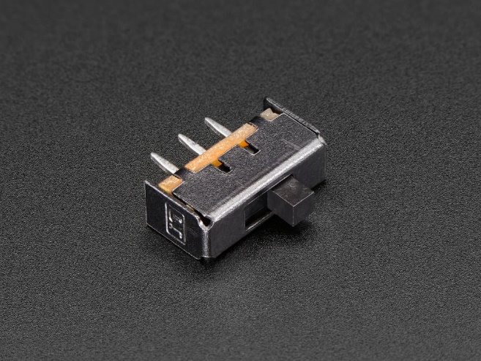

### Electrical Component Wiring and Mounting

For mounting the electrical components and wiring the components together, there are a few options to accomplish this:

1. Components mounted directly in 3D printed enclosure (panel mount switch jacks and slide switch)
2. 3D printed PCB/3D printed jig
3. Protoboard with breadboard friendly jacks
4. Combination of protoboard and panel mounts
5. Printed Circuit Board (PCB)

With each of these options there are a few different factors to consider:

* Ease of assembly for the maker
* Device cost
* Design complexity
* Device size

For each of these concepts the following components need to be included:

* Microcontroller
* Joystick Module
* 3x Switch Jack
* Slide Switch

#### Concept 1: Components mounted directly in 3D printed enclosure

This would use panel mount components for the slide switch and switch jacks, and would involve mounting the microcontroller directly in the enclosure. Wiring would be completed with free floating wires.

**Easy of assembly:** a lot of free floating wires, tricky to hold while soldering, tricky to keep them all straight, would need to daisy chain multiple ground wires together. If soldering while the components are mounted it could be hard to get in to solder, but if the components are free there is risk the wires may not reach.

**Device cost:** lower cost due to not having to buy protoboard or a PCB. Other components similar in price.

**Design complexity**: easy to design, easy to mount components where they fit best. Will need to consider how to mount the micro controller.

**Device size:** allows the device to be relatively compact since components can be placed anywhere in the enclosure that thy fit best.

#### Concept 2: 3D printed PCB/3D printed jig

This would involved a 3D printed board that the components would be mounted to and would help guide the wiring.

This could be similar to the Switch Input Module for the LipSync:

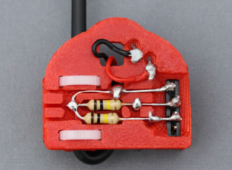

Female headers could be embedded in the 3D print for mounting the microcontroller and this could help guide the wires for connecting the switch jacks and slide switch to the microcontroller, and would likely be easier than free hanging wires. The switch jacks, slide switch, and microcontroller could all be mounted on this board, and the board could have any shape needed to fit in the enclosure and fit around the joystick component. There could be female headers that fit onto the male headers on the joystick board.

**Ease of assembly:** Likely easier than free hanging wires in Concept 1, but more complex than a PCB. The print would help guide the positioning and wiring of the various components.

**Device cost:** lower cost due to not having to buy protoboard or a PCB. Other components similar in price.

**Design complexity**: Relatively complex, positioning and wiring of each component needs to be considered in the board. Pieces need to fit properly.

**Device size:** allows the device to be compact since the printed board can take on any necessary shape.

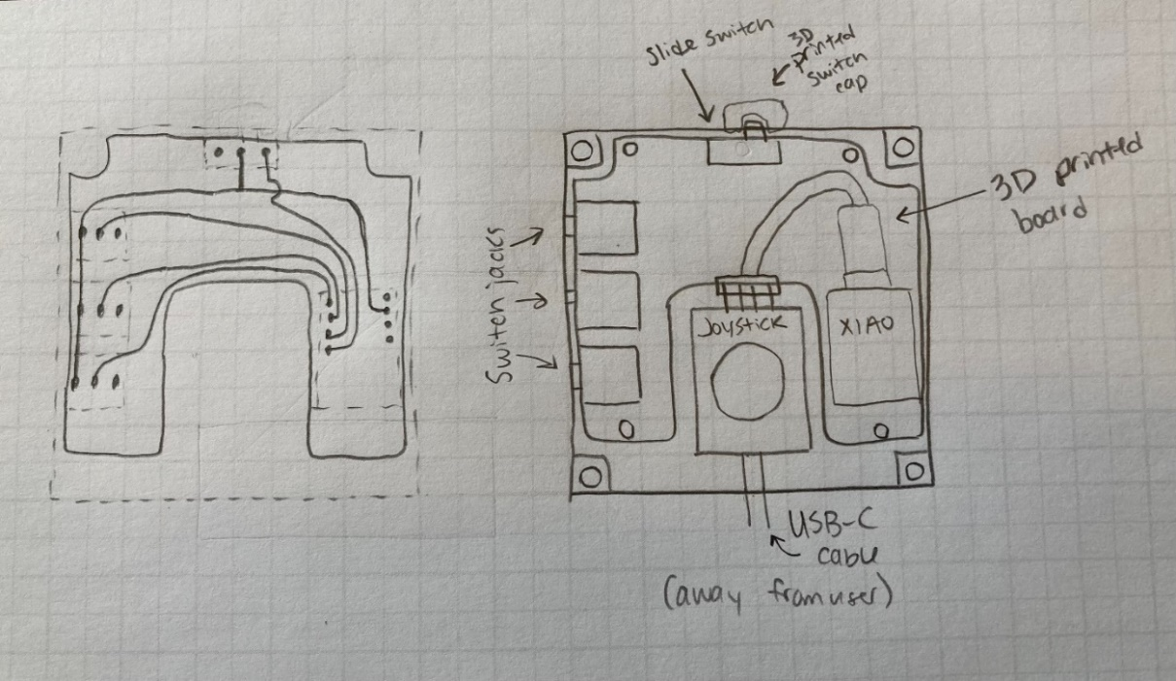

This concept was also tested out in CAD to see the real size of components relative to each other. This was the first attempt at laying out the components:

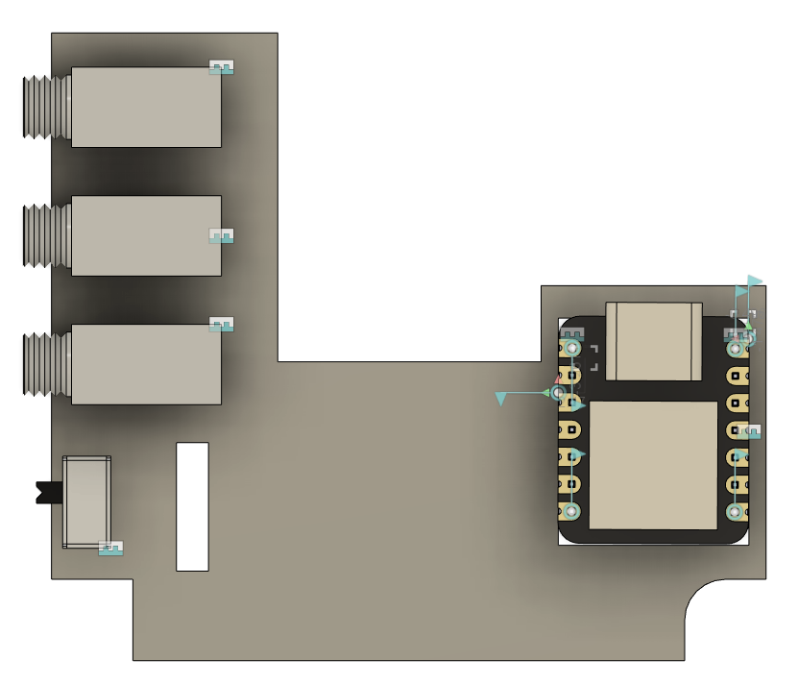

#### Concept 3: Protoboard with breadboard friendly jacks

**Ease of assembly:** Likely easier than concept 1 with the panel mounted components and free floating wires, and slightly easier than the 3D printed PCB, but likely somewhat comparable. If using stripboard, this will be more simple, but if using protoboard with individual pads this will be more complex as it will require solder bridges.

**Device cost:** Added cost of the protoboard. Depending on the board this could range from $2 to $6. Other components should be similar in price.

**Design complexity:** Relatively simple design, if the protoboard has screw holes these can be incorporated, otherwise will need to think about mounting the protoboard.

**Device size:** This depends on if using stripboard or single pad protoboard, but with stripboard as seen below space cannot be as optimized since the pads are connected, dictating where components can and cannot go. If using single pad protoboard, the design can be more compact, but this adds assembly complexity.

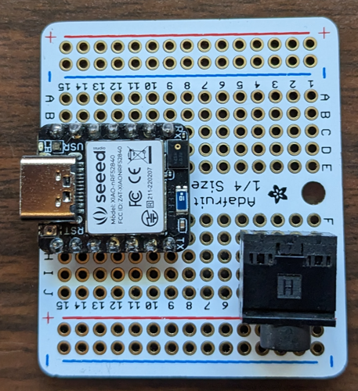 <https://www.adafruit.com/product/589>

3 breadboard friendly audio jacks could fit along one side of a quarter sized proto board, or the SeeedStudio XIAO board (same footprint as Adafruit AT Py) could fit along with 2 breadboard friendly audio jacks.

Another concept that was experimented with was using two protoboard with individual pads (rather than strip board) and attaching the two boards together using right angle male and female headers.

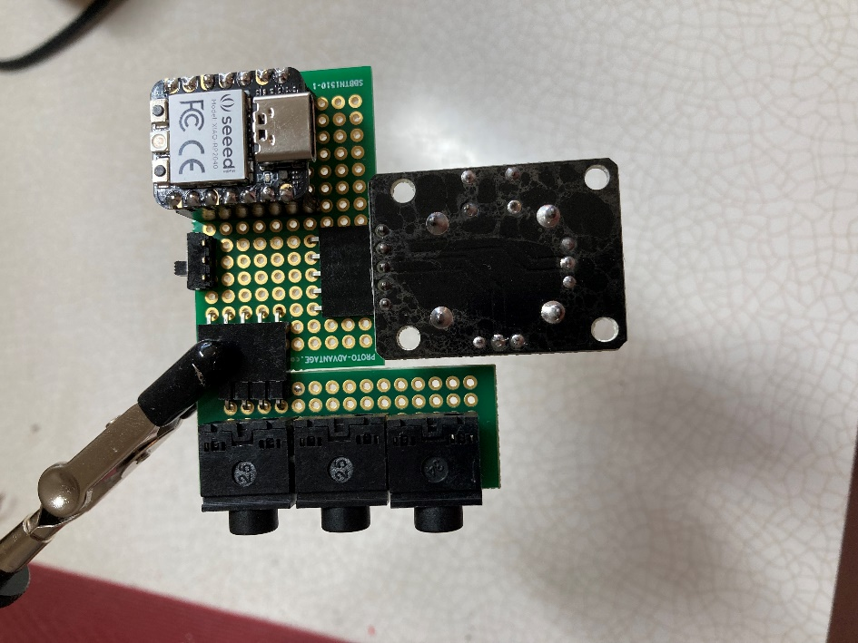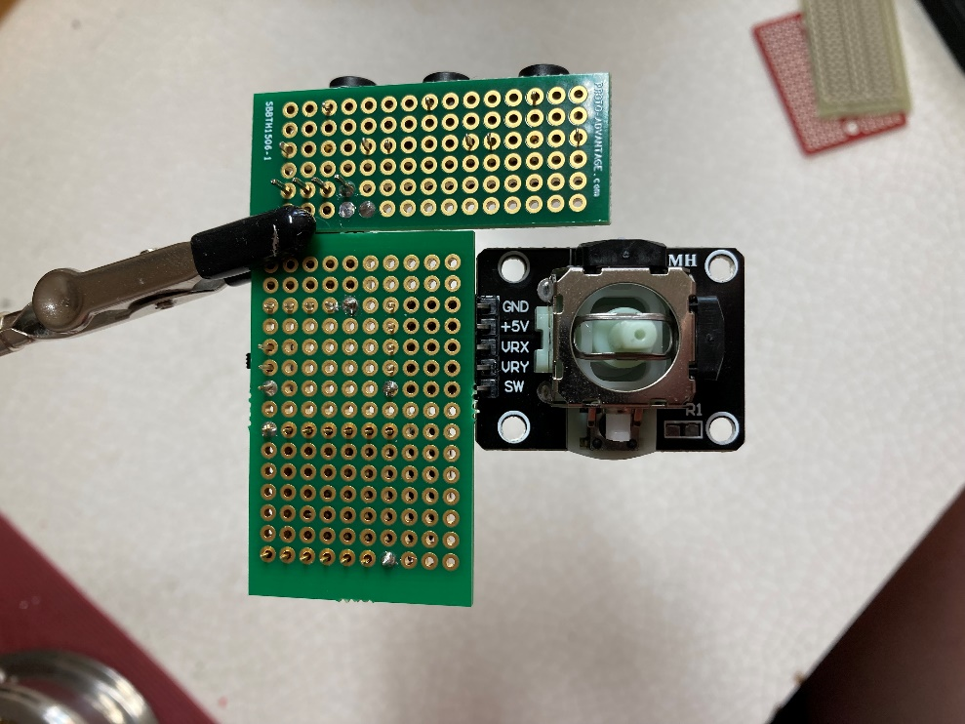

This concept has promise since it is relatively compact, and having the components on the “underside” of the protoboard decreases the height of the enclosure significantly. However, with these protoboards there is still the challenge of mounting them since they do not have screw holes, and they would need to be secure since the user would be plugging and unplugging switches from the mono jacks. Additionally, since it uses individual pads instead of stripboard, wiring would likely require solder bridges which means assembly would not be much easier than the 3D PCB.

#### Concept 4: Combination of protoboard and panel mounts

This concept would allow for the use of a smaller protoboard than concept 3, since not all components would need to be mounted on it. For example, the microcontroller and slide switch could mount to the protoboard and the mono jacks could be panel mounted. Another possibility is having the mono jacks and slide switch on the protoboard and then having the microcontroller mounted to the enclosure directly. This can also allow for a more compact layout than concept 3 if using one protoboard.

**Ease of assembly:** Slightly easier than concept 1 with all panel mounted components, but more difficult than concept 3 with a protoboard.

**Device cost:** Similar to concept 4, more than concept 1 and 2 due to added cost of protoboard.

**Design complexity:** Relatively simple, depending on the mounting of the protoboard.

**Device size:** Allows the enclosure to be more compact than concept 3 (if only using one board) since the layout of the parts is not defined by the size and layout of the protoboard.

#### Concept 5: Printed Circuit Board (PCB)

**Ease of assembly:** This would be the easiest of the options in terms of assembly, since the components could just be soldered to the board and wires would not need to be added between components. There would also be less room for error while assembling with this option.

**Device cost:** Adds approximately ~$30 to cost for a single build

**Design complexity:** It takes time to prototype, order, and test PCB boards, so the design complexity is likely too high for the timeline of the initial design.

**Device size:** A custom PCB can be made in any shape, therefore allowing the size to be relatively compact.

**Discussion:** One PCB design could be used across different devices.

#### Selection

For the initial version of this design, version 0.9, concept 2 with the 3D printed circuit board was selected. This option is easier to assemble than concept 1; lower cost than concept 3, 4, and 5; and is only marginally more difficult to assemble than concept 3. Though concept 5 would be easier to assemble, the cost is much higher, and the design time is not feasible for this design iteration.

There is a possibility of creating a PCB at a later stage in the design process, and having two options for the build depending on if someone is building one or multiple. When building multiple joysticks, the cost of the PCB per joystick drops significantly, making it a more viable option when doing bulk orders.

While designing the 3D printed circuit board, the idea of implementing concept 5 at a later date will be kept in mind, and the 3D printed circuit board will be designed to be able to easily transition to a custom ordered PCB at a later date.

## Firmware Design

For this joystick, the joystick mode and mouse mode will be captured on one firmware, with a slide switch to switch between modes. This switch will be checked once upon startup, and will determine if the device will be set up as a joystick/HID gamepad or as a mouse. If switching between joystick and mouse mode, the device will need to be unplugged and plugged back into the host device.

For both joystick and mouse output, there is a deadzone where if the joystick readings are below a certain value, the output will be zero. This code uses a radial deadzone, which if mapped would have a circular shape, and the radius of this deadzone is set in a variable at the start of the code. If the joystick is experiencing drift, this deadzone may need to be increased. If small movements are not corresponding to outputs, this value may need to be decreased.

### Joystick Mode

For the joystick mode portion of the code, the code from the MMC OpenAT Joysticks, the Birch Mini Joystick – U and the Oak Compact Joystick – U will be used and modified. The main changes from this code will be incorporating the switch inputs and modifying the code to work with the Adafruit QT Py SAMD21 microcontroller.

This joystick has three accessible switch jacks, and has one built in switch in the joystick that is activated when the joystick is pressed down. These switches will be mapped as buttons 1 to 4 on the gamepad output.

### Mouse Mode

For the mouse mode portion of the code, the mouse functions were added into the joystick code, with conditional statements so they are only outputted when in mouse mode. The three switch jacks (labelled A, B, C from left to right) are mapped as left click, middle click (for scroll), and right click (from left to right). The joystick press down button is mapped to left click.

Since the joystick portion of the code requires the use of the Adafruit TinyUSB stack, and the typical Mouse.h library uses the Arduino USB stack, an alternative library had to be used that allowed for Mouse functionality with the TinyUSB stack. [This library was found on GitHub by user cyborg5](https://github.com/cyborg5/TinyUSB_Mouse_and_Keyboard).

## Mechanical Design

The mechanical design is largely dependant on the electrical component wiring and mounting. After selecting concept 2 for the electrical design, the enclosure and 3D PCB could be designed. The current Analog Thumbstick on the MMC library has a footprint of 69 mm by 69 mm, so effort will be made for this new enclosure design to be similar in size.

In this enclosure, it will be ensured that the mono jacks and slide switch are mounted in a way that is very secure since the user will be applying forces to these parts.

The enclosure will also include captive M3 nuts to be used with the MMC Joystick camera mount adapter.

The current Analog Thumbstick on the MMC library uses 4 screws to secure the enclosure, and 4 screws to secure the joystick to the enclosure. This approach will be used for this enclosure as well, for both simplicity of design, and strength of the connection. Since the user will be applying forces to the joystick that could be quite large, this needs to be mounted to the enclosure in a strong and secure way. Relying on snap fits can also be difficult if printer tolerances are very different. This enclosure, like the Analog Thumbstick, will use 8 size 4-24 self threading sheet metal screws. The 3D PCB will be secured using the same screws as the ones holding together the enclosure.

# Minimum Viable Product – V0.9

## Summary

* Cost
  + Unit cost: $42.74 ($34.74 for parts, $8 shipping)
  + Total maker cost: $64.33 ($56.33 for parts, $8 shipping)
* Print time: 4 hours 53 mins
* Total 3D printer filament used: 41 g
* Approximate build time: 1 hour??
* Size:
  + Total Height: 4.0 cm with original topper
  + Enclosure height: 2.7 cm
  + Width: 7.0 cm
  + Length: 7.0 cm

### Bill of Materials

The following components were selected based on price, availability, and components used internally for MMC designs.

|  |  |  |  |  |  |  |  |
| --- | --- | --- | --- | --- | --- | --- | --- |
| **Part Name** | **QTY** | **QTY /PKG** | **$/PKG** | **PKG QTY** | **$/Unit** | **Extended** | **Total** |
| [Joystick (PS2)](https://www.amazon.ca/dp/B089VXPHDH?_encoding=UTF8&psc=1&ref_=cm_sw_r_cp_ud_dp_GGTEDME4PM2P27SG86P7) | 1 | 10 | $ 23.99 | 1 | $ 2.40 | $ 2.40 | $ 23.99 |
| [USB-C cable, 6 ft](https://www.digikey.ca/en/products/detail/cvilux-usa/DH-20M50053/13177348) | 1 | 1 | $ 3.18 | 1 | $ 3.18 | $ 3.18 | $ 3.18 |
| [Adafruit QT Py SAMD21](https://www.digikey.ca/en/products/detail/adafruit-industries-llc/4600/13543375) | 1 | 1 | $ 10.79 | 1 | $ 10.79 | $ 10.79 | $ 10.79 |
| [3.5 mm mono jack, panel mount](https://www.digikey.ca/en/products/detail/cui-devices/MJ-3502/281321) | 3 | 1 | $ 2.32 | 3 | $ 2.32 | $ 6.96 | $ 6.96 |
| [Slide switch, right angle](https://www.digikey.ca/en/products/detail/c-k/OS102011MA1QS1/1981431) | 1 | 1 | $ 0.75 | 1 | $ 0.75 | $ 0.75 | $ 0.75 |
| [Right angle female header, 5 position](https://www.digikey.ca/en/products/detail/sullins-connector-solutions/PPTC051LGBN-RC/775899) | 1 | 1 | $ 0.93 | 1 | $ 0.93 | $ 0.93 | $ 0.93 |
| [Female header, 7 position, single row, 0.100"](https://www.digikey.ca/en/products/detail/sullins-connector-solutions/PPTC071LFBN-RC/810146) | 2 | 1 | $ 0.85 | 2 | $ 0.85 | $ 1.70 | $ 1.70 |
| [#4 Metal Screw, 3/8″ Length](https://www.digikey.ca/en/products/detail/serpac/6005/307599) | 8 | 1 | $ 0.60 | 8 | $ 0.60 | $ 4.80 | $ 4.80 |
| [Wire, 1 foot, colour 1](https://www.digikey.ca/en/products/detail/cnc-tech/3122-24-1-0500-007-1-TS/16396741) | 1 | 1 | $ 0.70 | 1 | $ 0.70 | $ 0.70 | $ 0.70 |
| [Wire, 1 foot, colour 2](https://www.digikey.ca/en/products/detail/cnc-tech/1569-26-1-0500-003-1-TS/15853701) | 1 | 1 | $ 0.72 | 1 | $ 0.72 | $ 0.72 | $ 0.72 |
| [Ziptie](https://www.digikey.ca/en/products/detail/te-connectivity/2-604771-9/2259327) | 1 | 1 | $ 0.25 | 1 | $ 0.25 | $ 0.25 | $ 0.25 |
| [M3 hex nut x2](https://www.digikey.ca/en/products/detail/b-f-fastener-supply/MHNZ-003/274973) | 2 | 1 | $ 0.27 | 2 | $ 0.27 | $ 0.54 | $ 0.54 |
| [(Optional for mount) M3x12mm screw x2](https://www.digikey.ca/en/products/detail/apm-hexseal/RM3X12MM-2701/2063201) | 0 | 1 | $ 1.11 | 0 | $ 1.11 | - | - |
| [(Optional for mount) Tee nut](https://www.homedepot.ca/product/paulin-1-4-inch-20-tee-nuts-4-prong-5-16-inch-barrel-length/1000129429) | 0 | 1 | $ 0.48 | 0 | $ 0.48 | - | - |
| Digikey shipping (if spending less than $100) | 1 | 1 | $ 8.00 | 1 | $ 8.00 | $ 8.00 | $ 8.00 |

## Detailed Design

### Electrical Design

#### Component Layout and Wiring

From the initial concept above, the 3D printed circuit board was created. The mono jacks will come out of the left side (from the user’s point of view), the slide switch will face the user, and the USB cable from the microcontroller will come out of the enclosure away from the user. The three screw holes in the corner are positioned to fit onto posts in the enclosure and “sandwich” between the top and bottom of the enclosure, using the same screws.

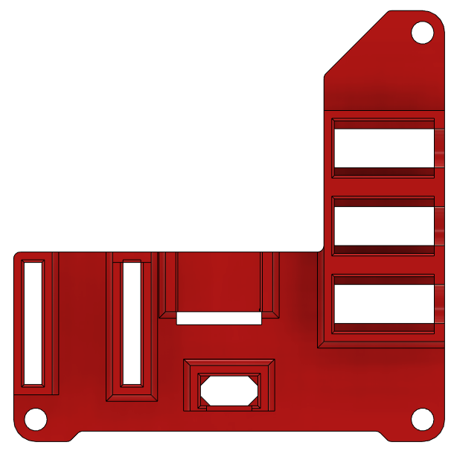 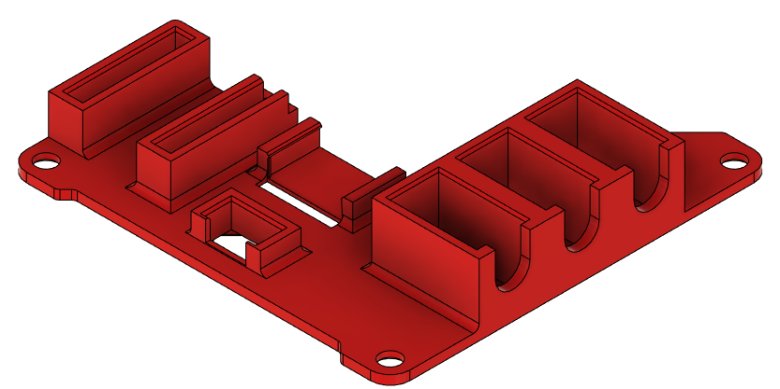

7 pin female headers for the microcontroller were included for ease of assembly, and ease of changing the microcontroller out if needed. These are press fit into the 3DP circuit board. For the joystick, there is a 5 pin right angle female header, and this is press fit into the enclosure with small bumps to keep it in place while wiring.

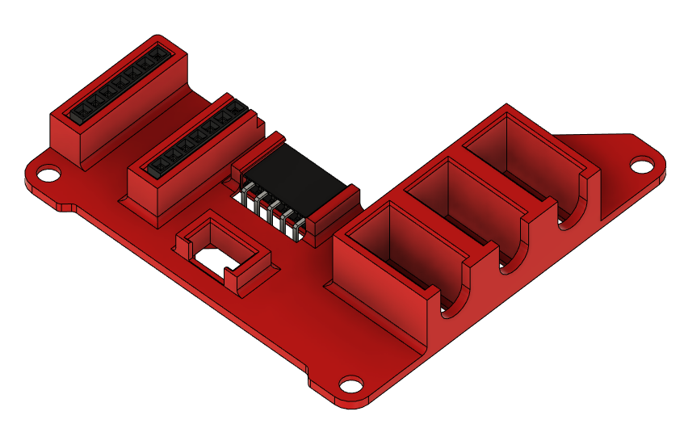

The microcontroller (with male headers soldered to it) then presses into the female headers to secure it in place. The joystick right angle headers slide into the female right angle headers. The slide switch is press fit into the surrounding 3D print, and has some material in the corners on the bottom to prevent it from going “through” the board. The mono jacks are a looser fit, but have panel mounts to keep them in place. There is also material on the bottom of the mono jacks to keep them from going “through” the board. In the picture below, the board is upside down, in reality the joystick will be rightside up and all the other parts will be upside down, this was to reduce the overall height of the enclosure.

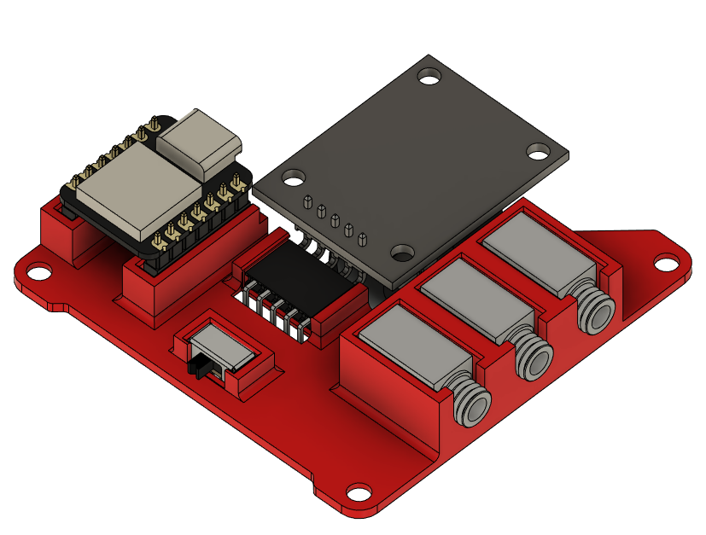

The below picture is an earlier iteration of the design, but shows the nuts installed on the mono jacks to keep them in place.

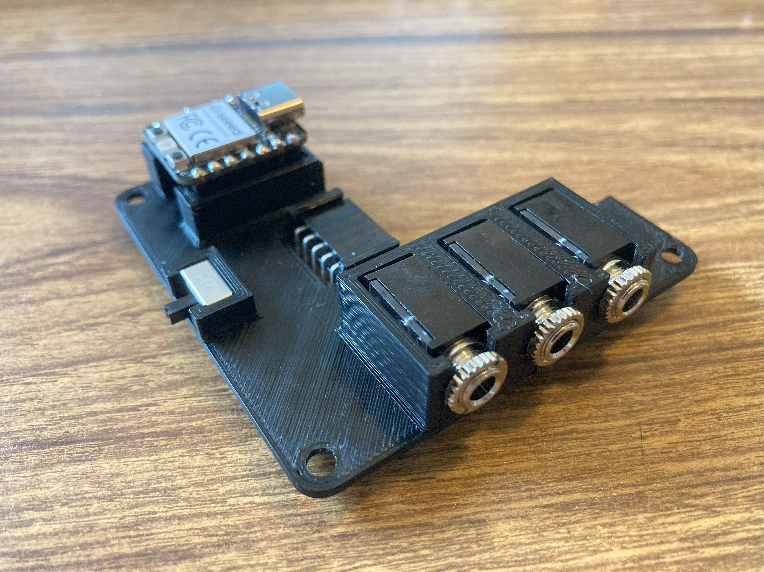

Below the board is rightside up, all of the leads to the electrical parts are facing upwards, and this is where the wires would be soldered.

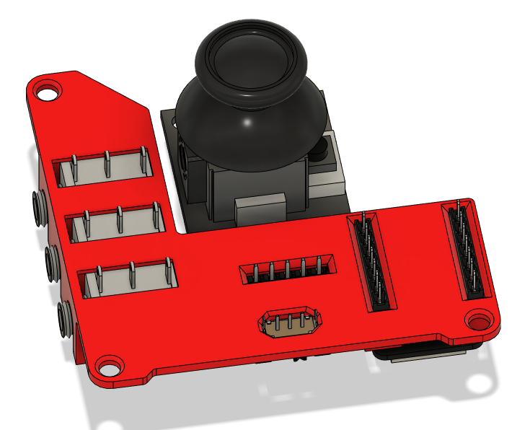

Below is a diagram showing the wiring of the electronics, for the joystick X and Y, analog pins had to be used, but for the rest the digital pins could be changed if it made wiring easier.

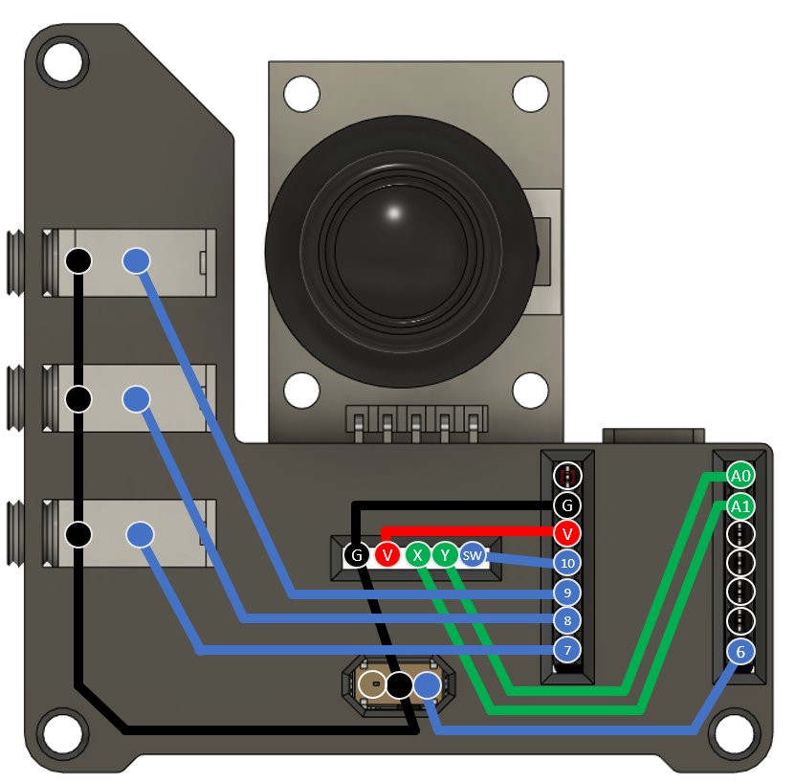

The wiring isn’t the easiest, and this could be improved, there are also some wired that must go on top of other wires, which if not done carefully could get messy.

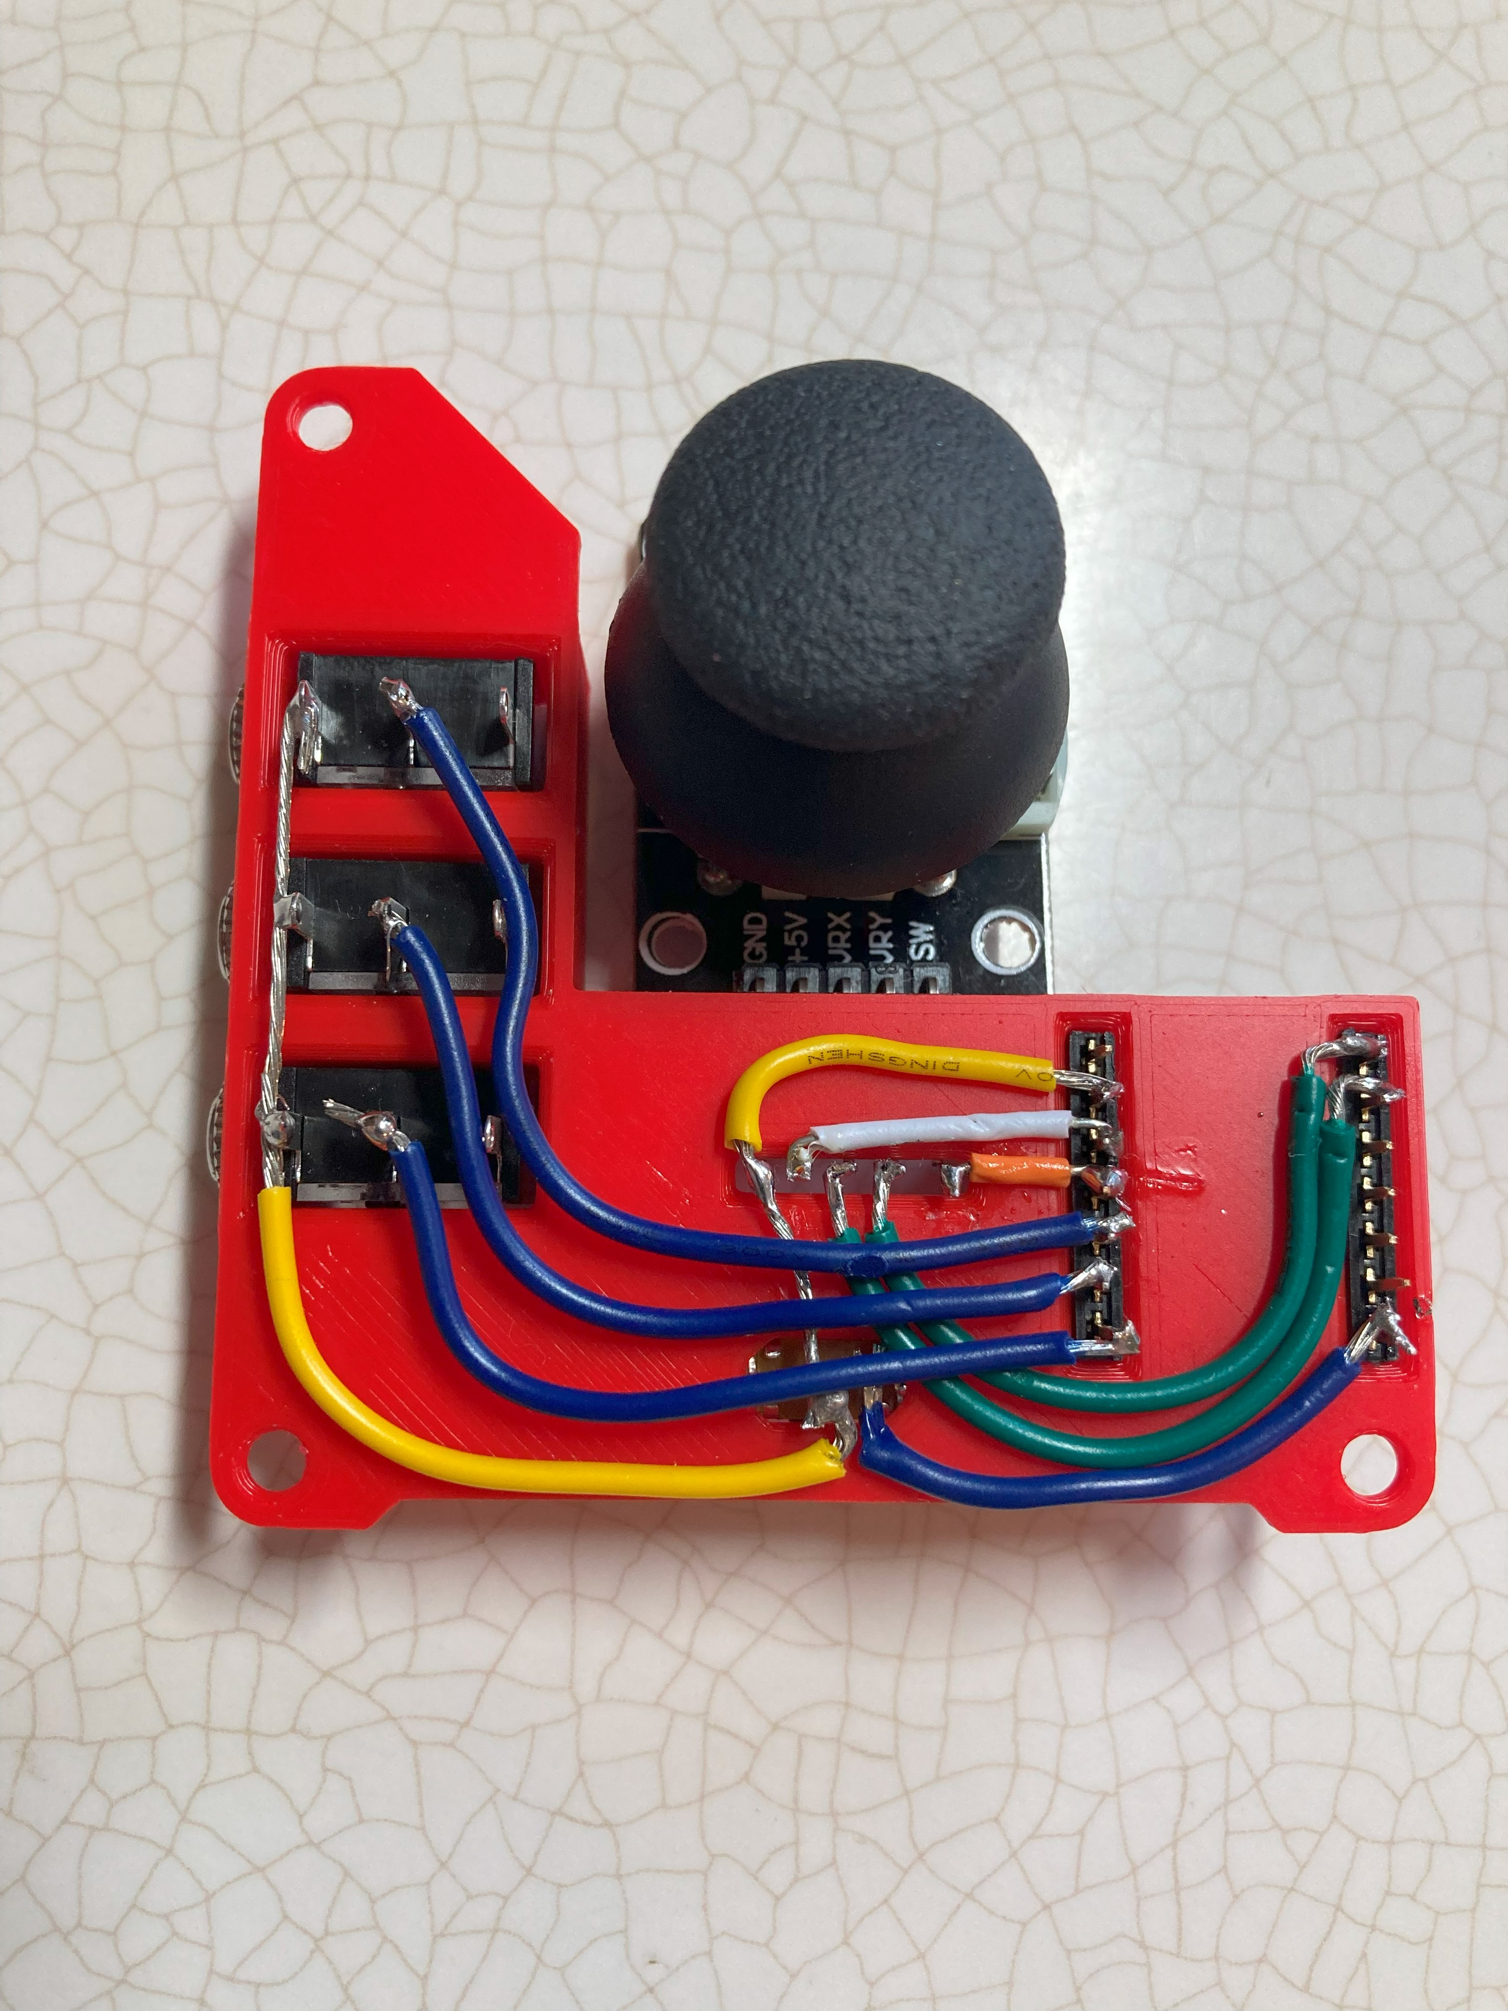

### Mechanical Design

#### Overview

On the outside of the enclosure, there are a few key features. On the side facing the user, is the mode selection slide switch and the works “Mouse” and “Joystick” showing the positions for the two modes. On the right side of the enclosure “MMC” is engraved.

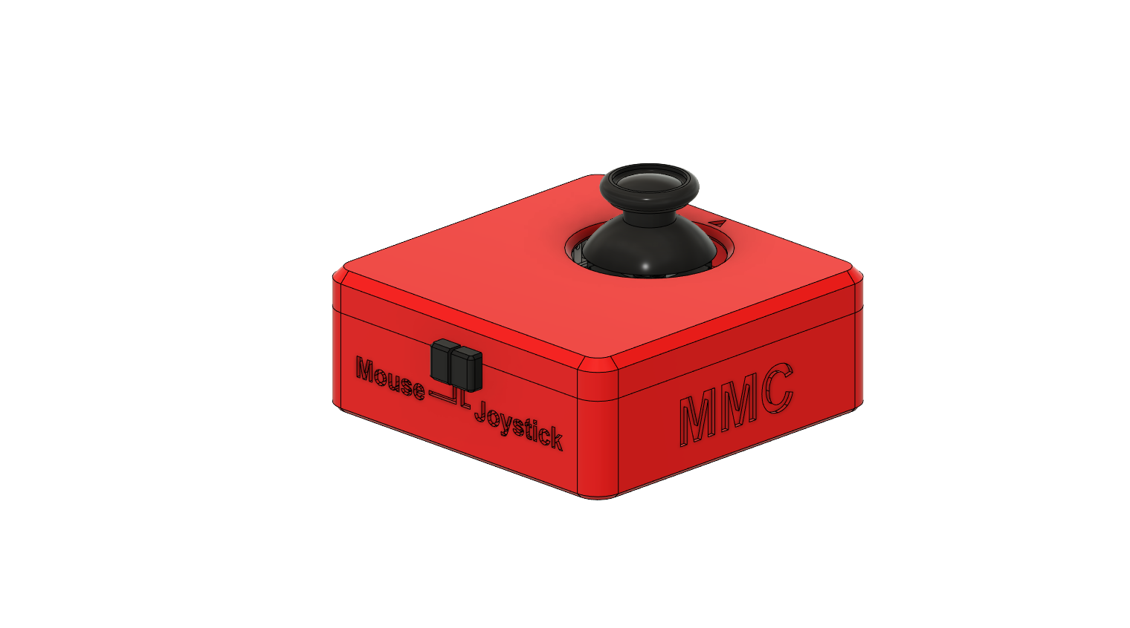

On the left side are the three mono jacks, labelled A, B, C from left to right. On the side facing away from the user is the USB cable exit and the name of the joystick “Cedar” is engraved.

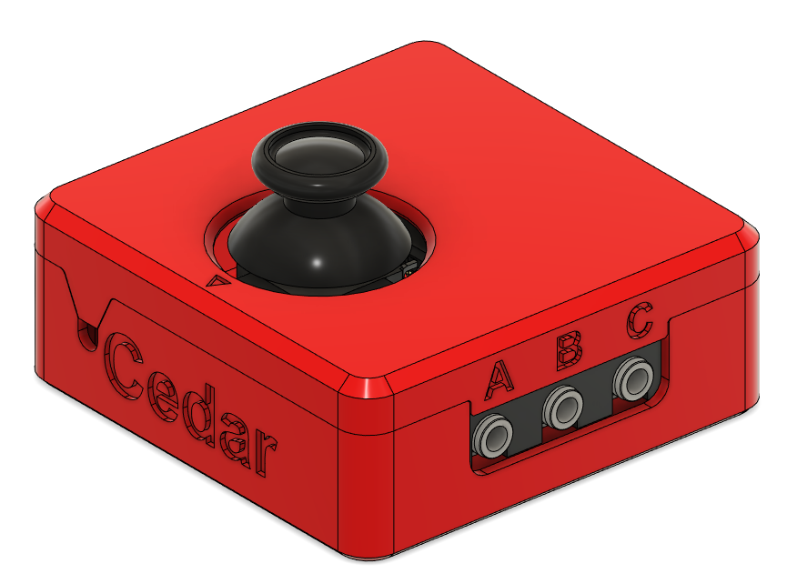

On the top of the joystick is a small triangle arrow, which points in the “up” direction of the joystick.

#### Assembled Prototype

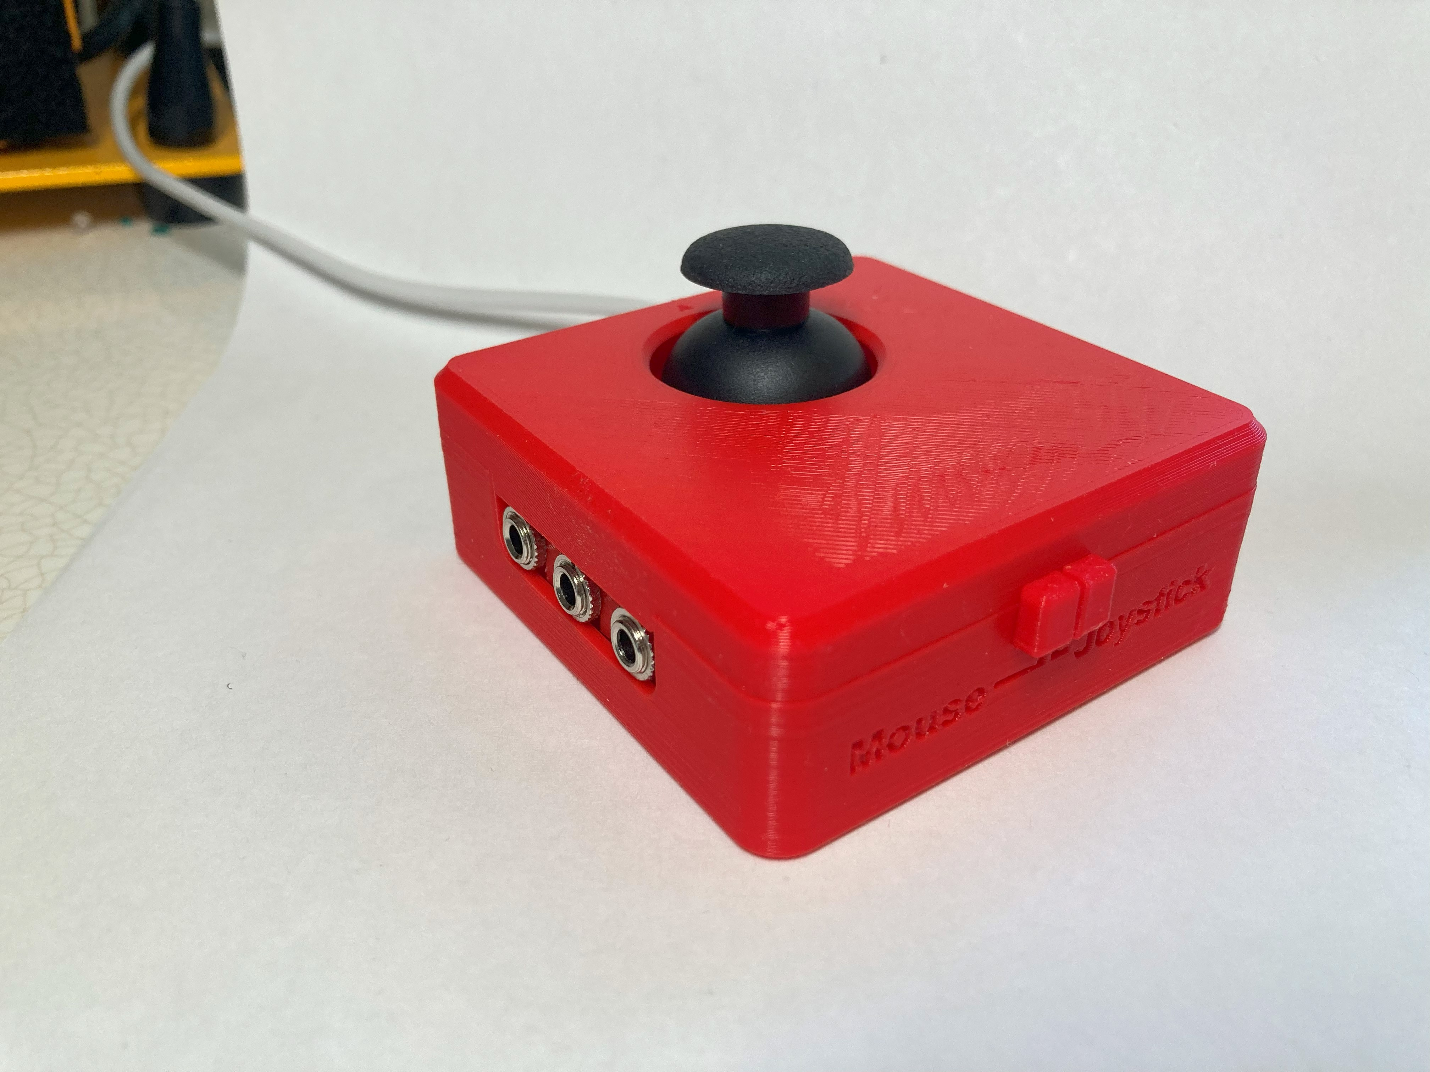 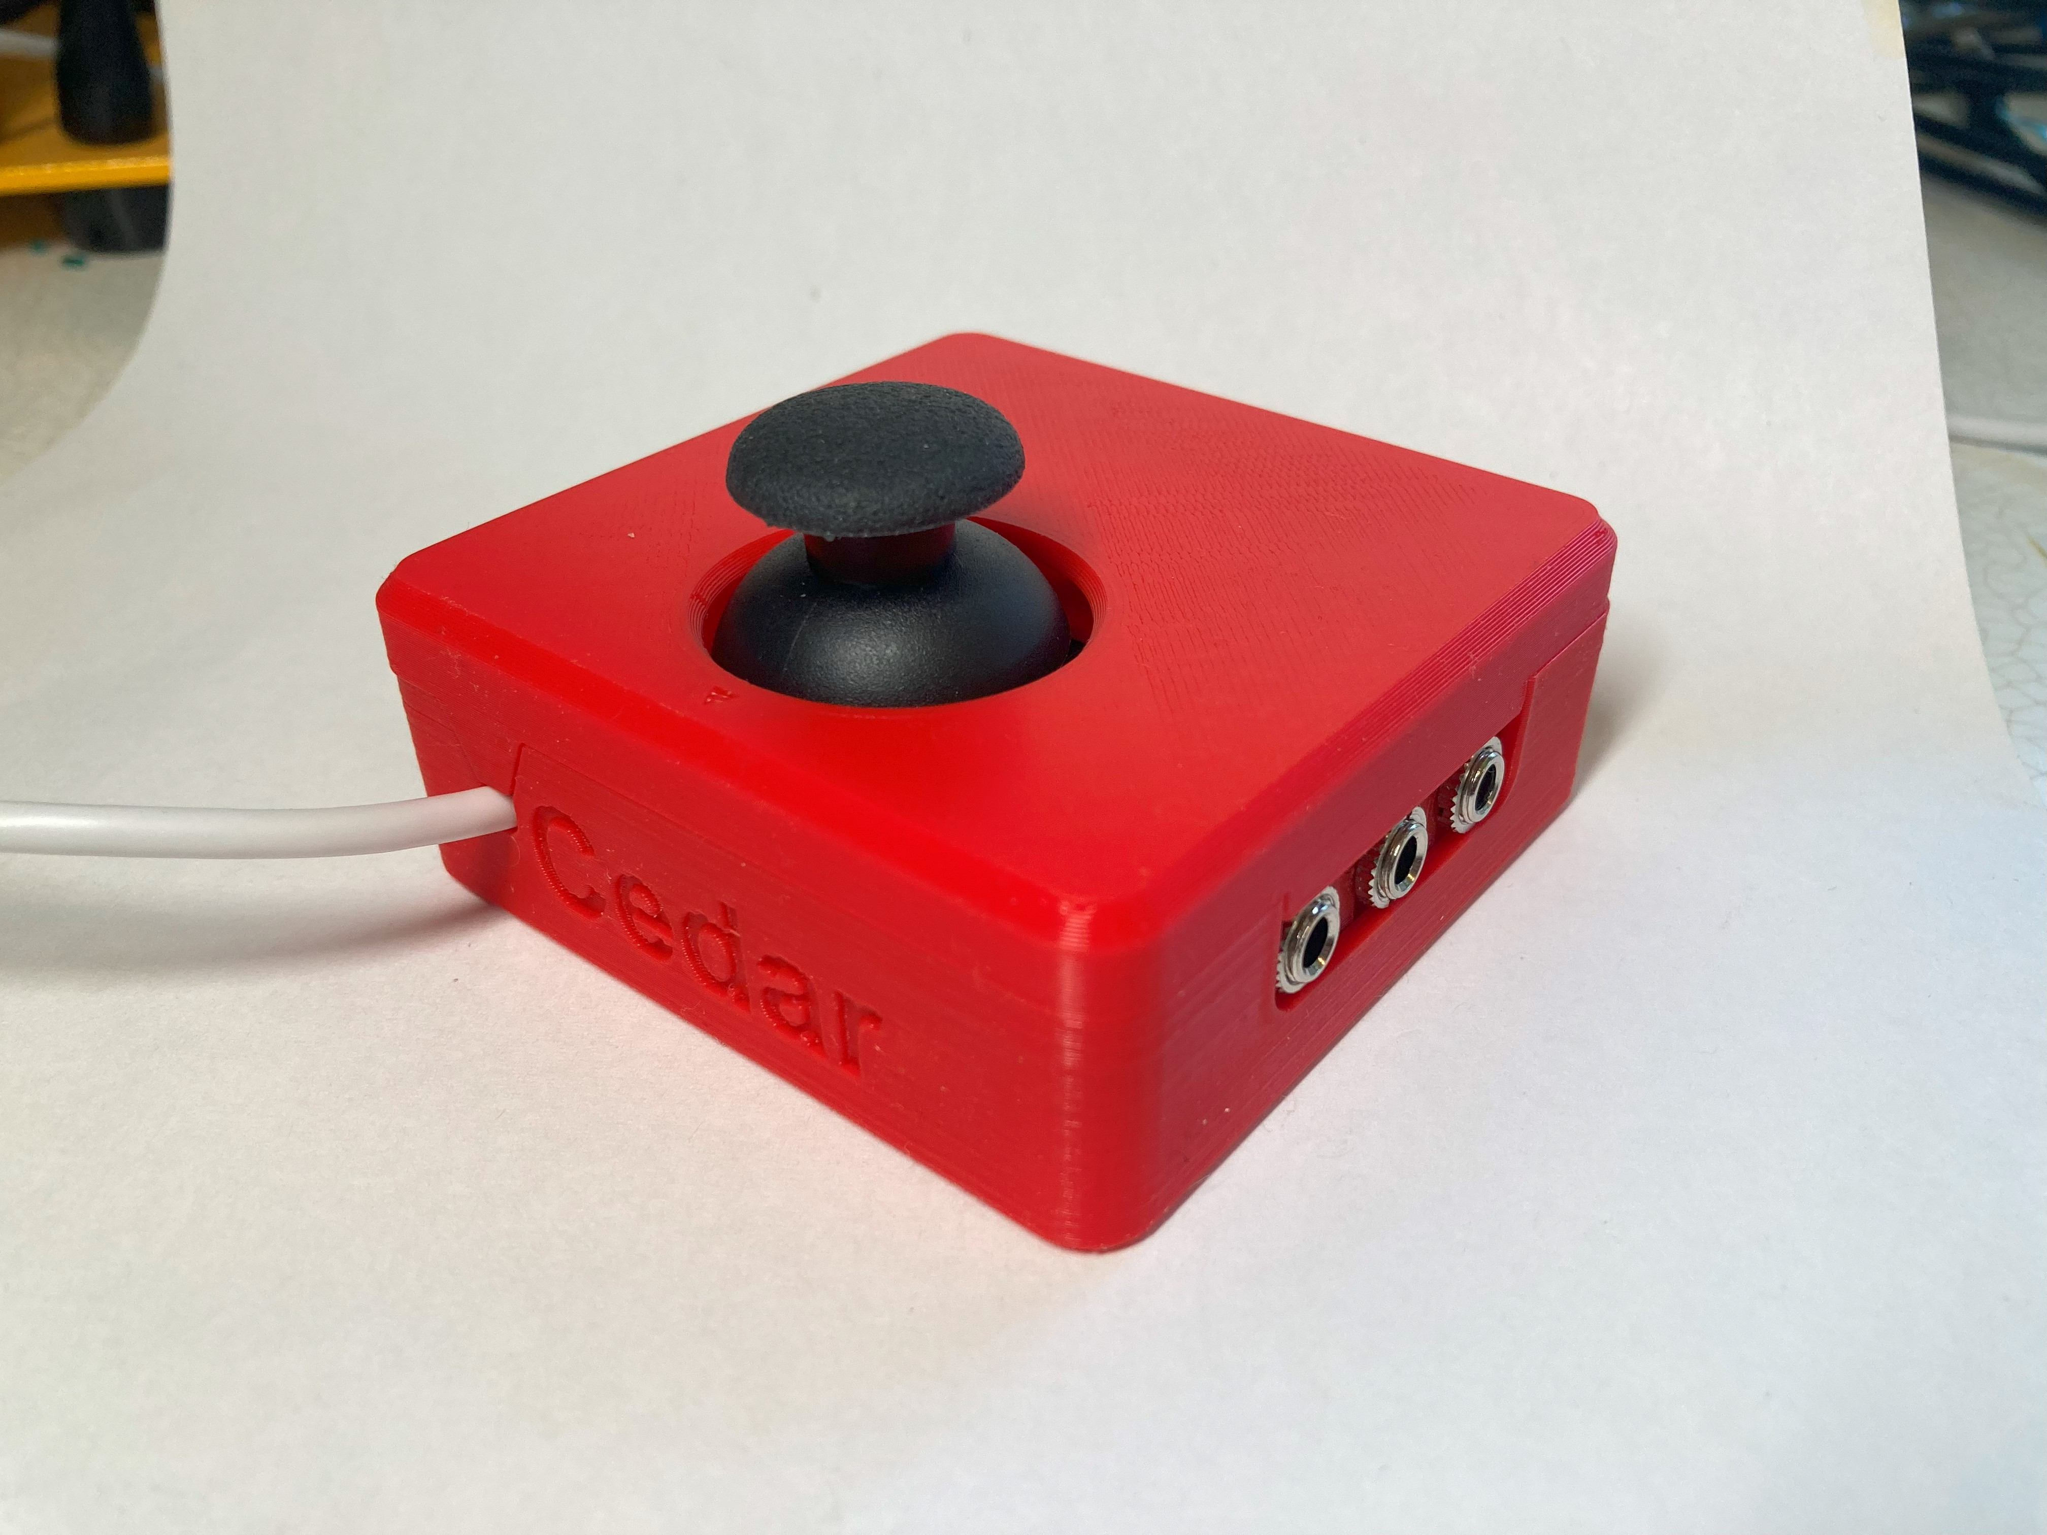

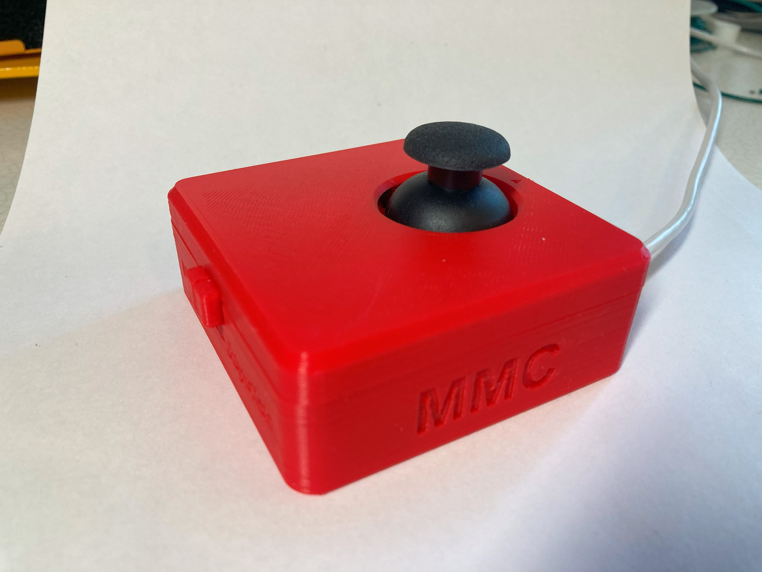

#### Enclosure Bottom

##### Joystick Mounting

In the bottom of the joystick there are four posts to mount the joystick with holes that are 2.68 mm in diameter. They fit self tapping sheet metal screws, size 4-24.

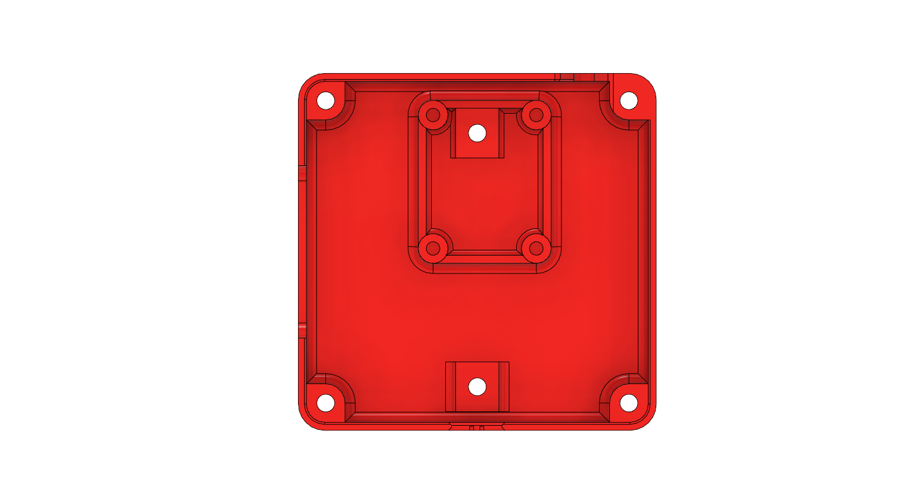

For this joystick in particular, which is linked in the Bill of Materials, this is the hole spacing:

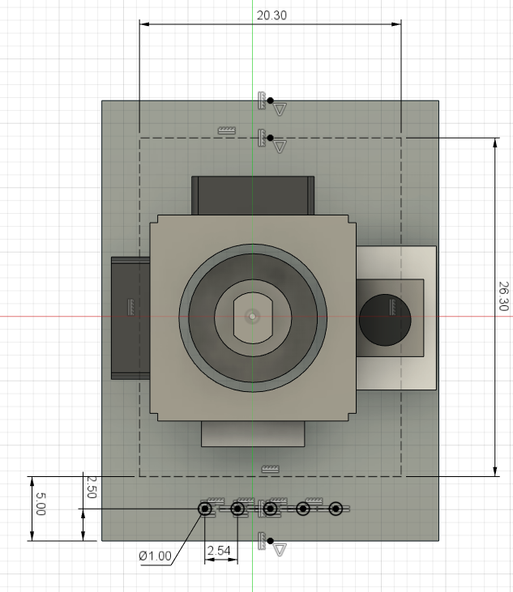 Hole spacing: 20.3 mm x 26.3 mm

##### Mounting – Captive nuts

It was decided that this design should incorporate a way to mount the joystick when not used on a tabletop. To do this, two slots for captive nuts were added, which would then screw into a separate mount adapter which will have the mounting hardware in it. Here, two M3 hex nuts are used. The centres of these nuts are 50.0 mm apart. These two slots are seen in the photos above, and then in a closer view below. As seen in the photo, around the hole above the captive nut, which would be printed unsupported, there are small single layer rectangles, [this is a best practice when 3D printing unsupported holes.](https://www.hydraresearch3d.com/design-rules#unsupported-holes)

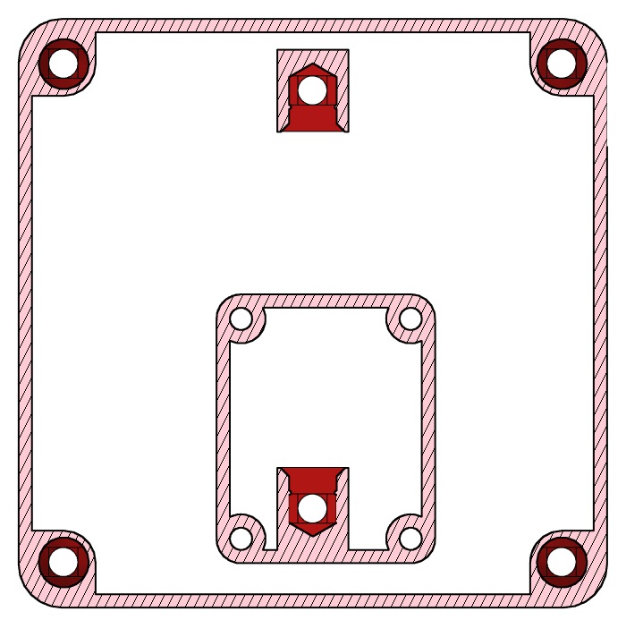 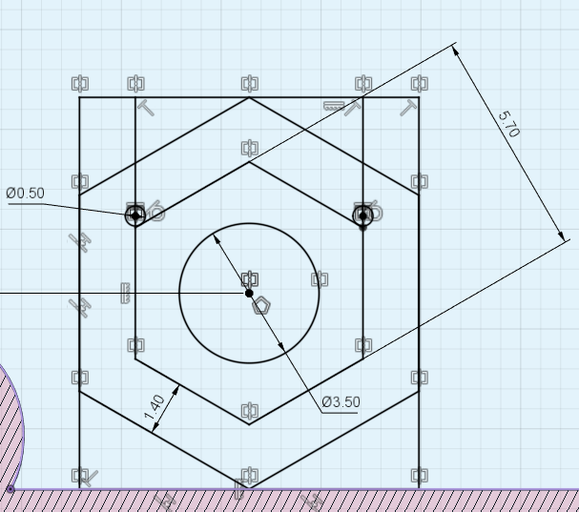

50mm

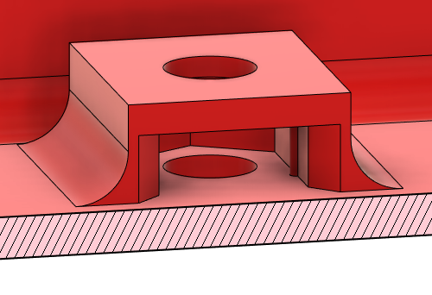

##### 3D Printed Circuit Board Mounting and Cutouts

To mount the 3D Printed Circuit Board, the existing screw holes to assemble the enclosure will be used. The posts with the screw holes were made shorter by 2.0 mm for the three posts that will hold the PCB, this is for the 1.6 mm thickness of the board plus 0.4 mm of clearance to account for printer tolerances and surface roughness so that there isn’t a gap between the top and bottom of the enclosure. The board sits on top of these posts, and there are cut-outs for the mono jacks to fit and for the slide switch.

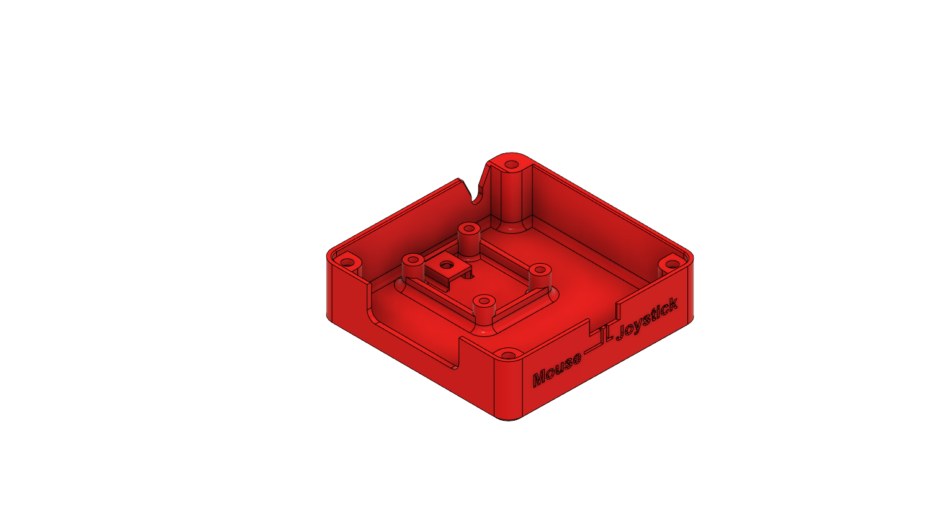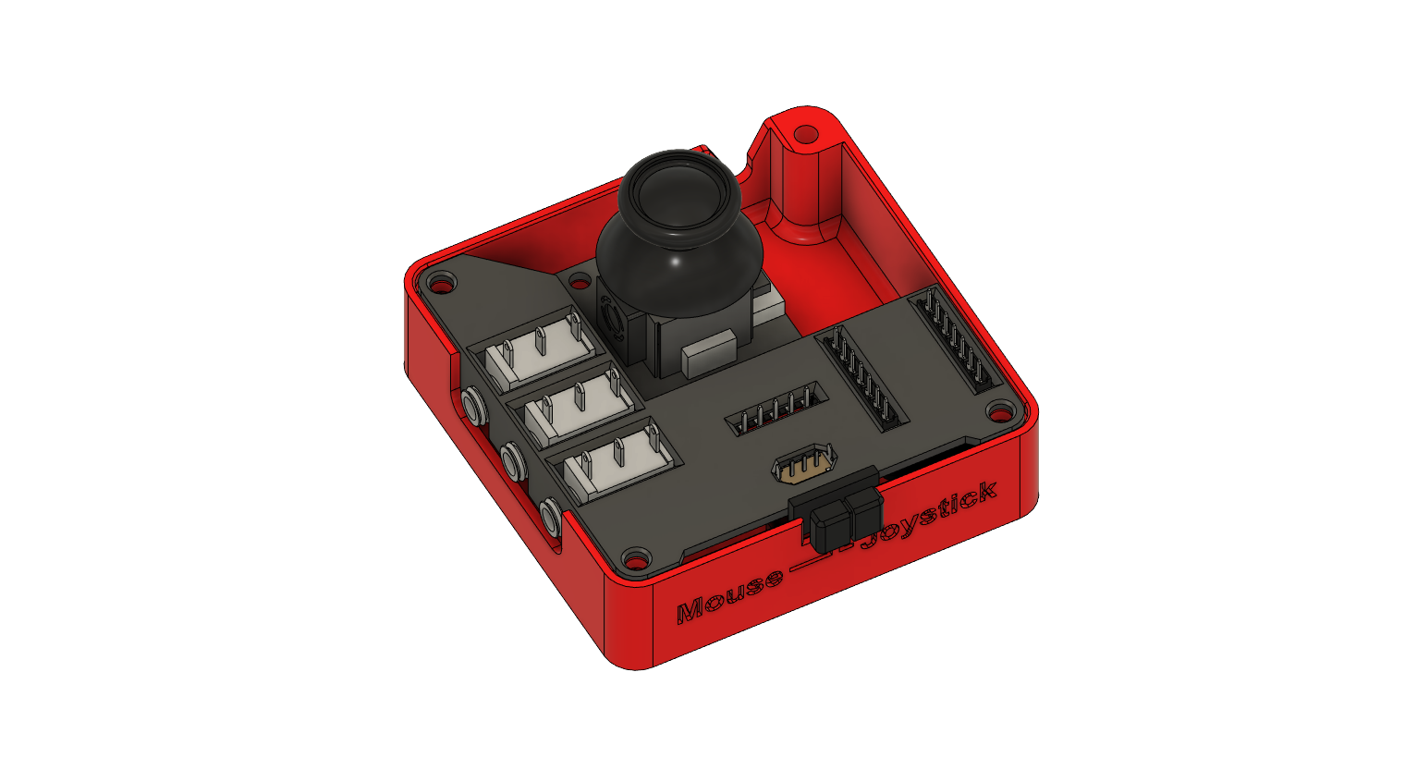

Lastly, there is a cut-out at the back where the USB cable exits.

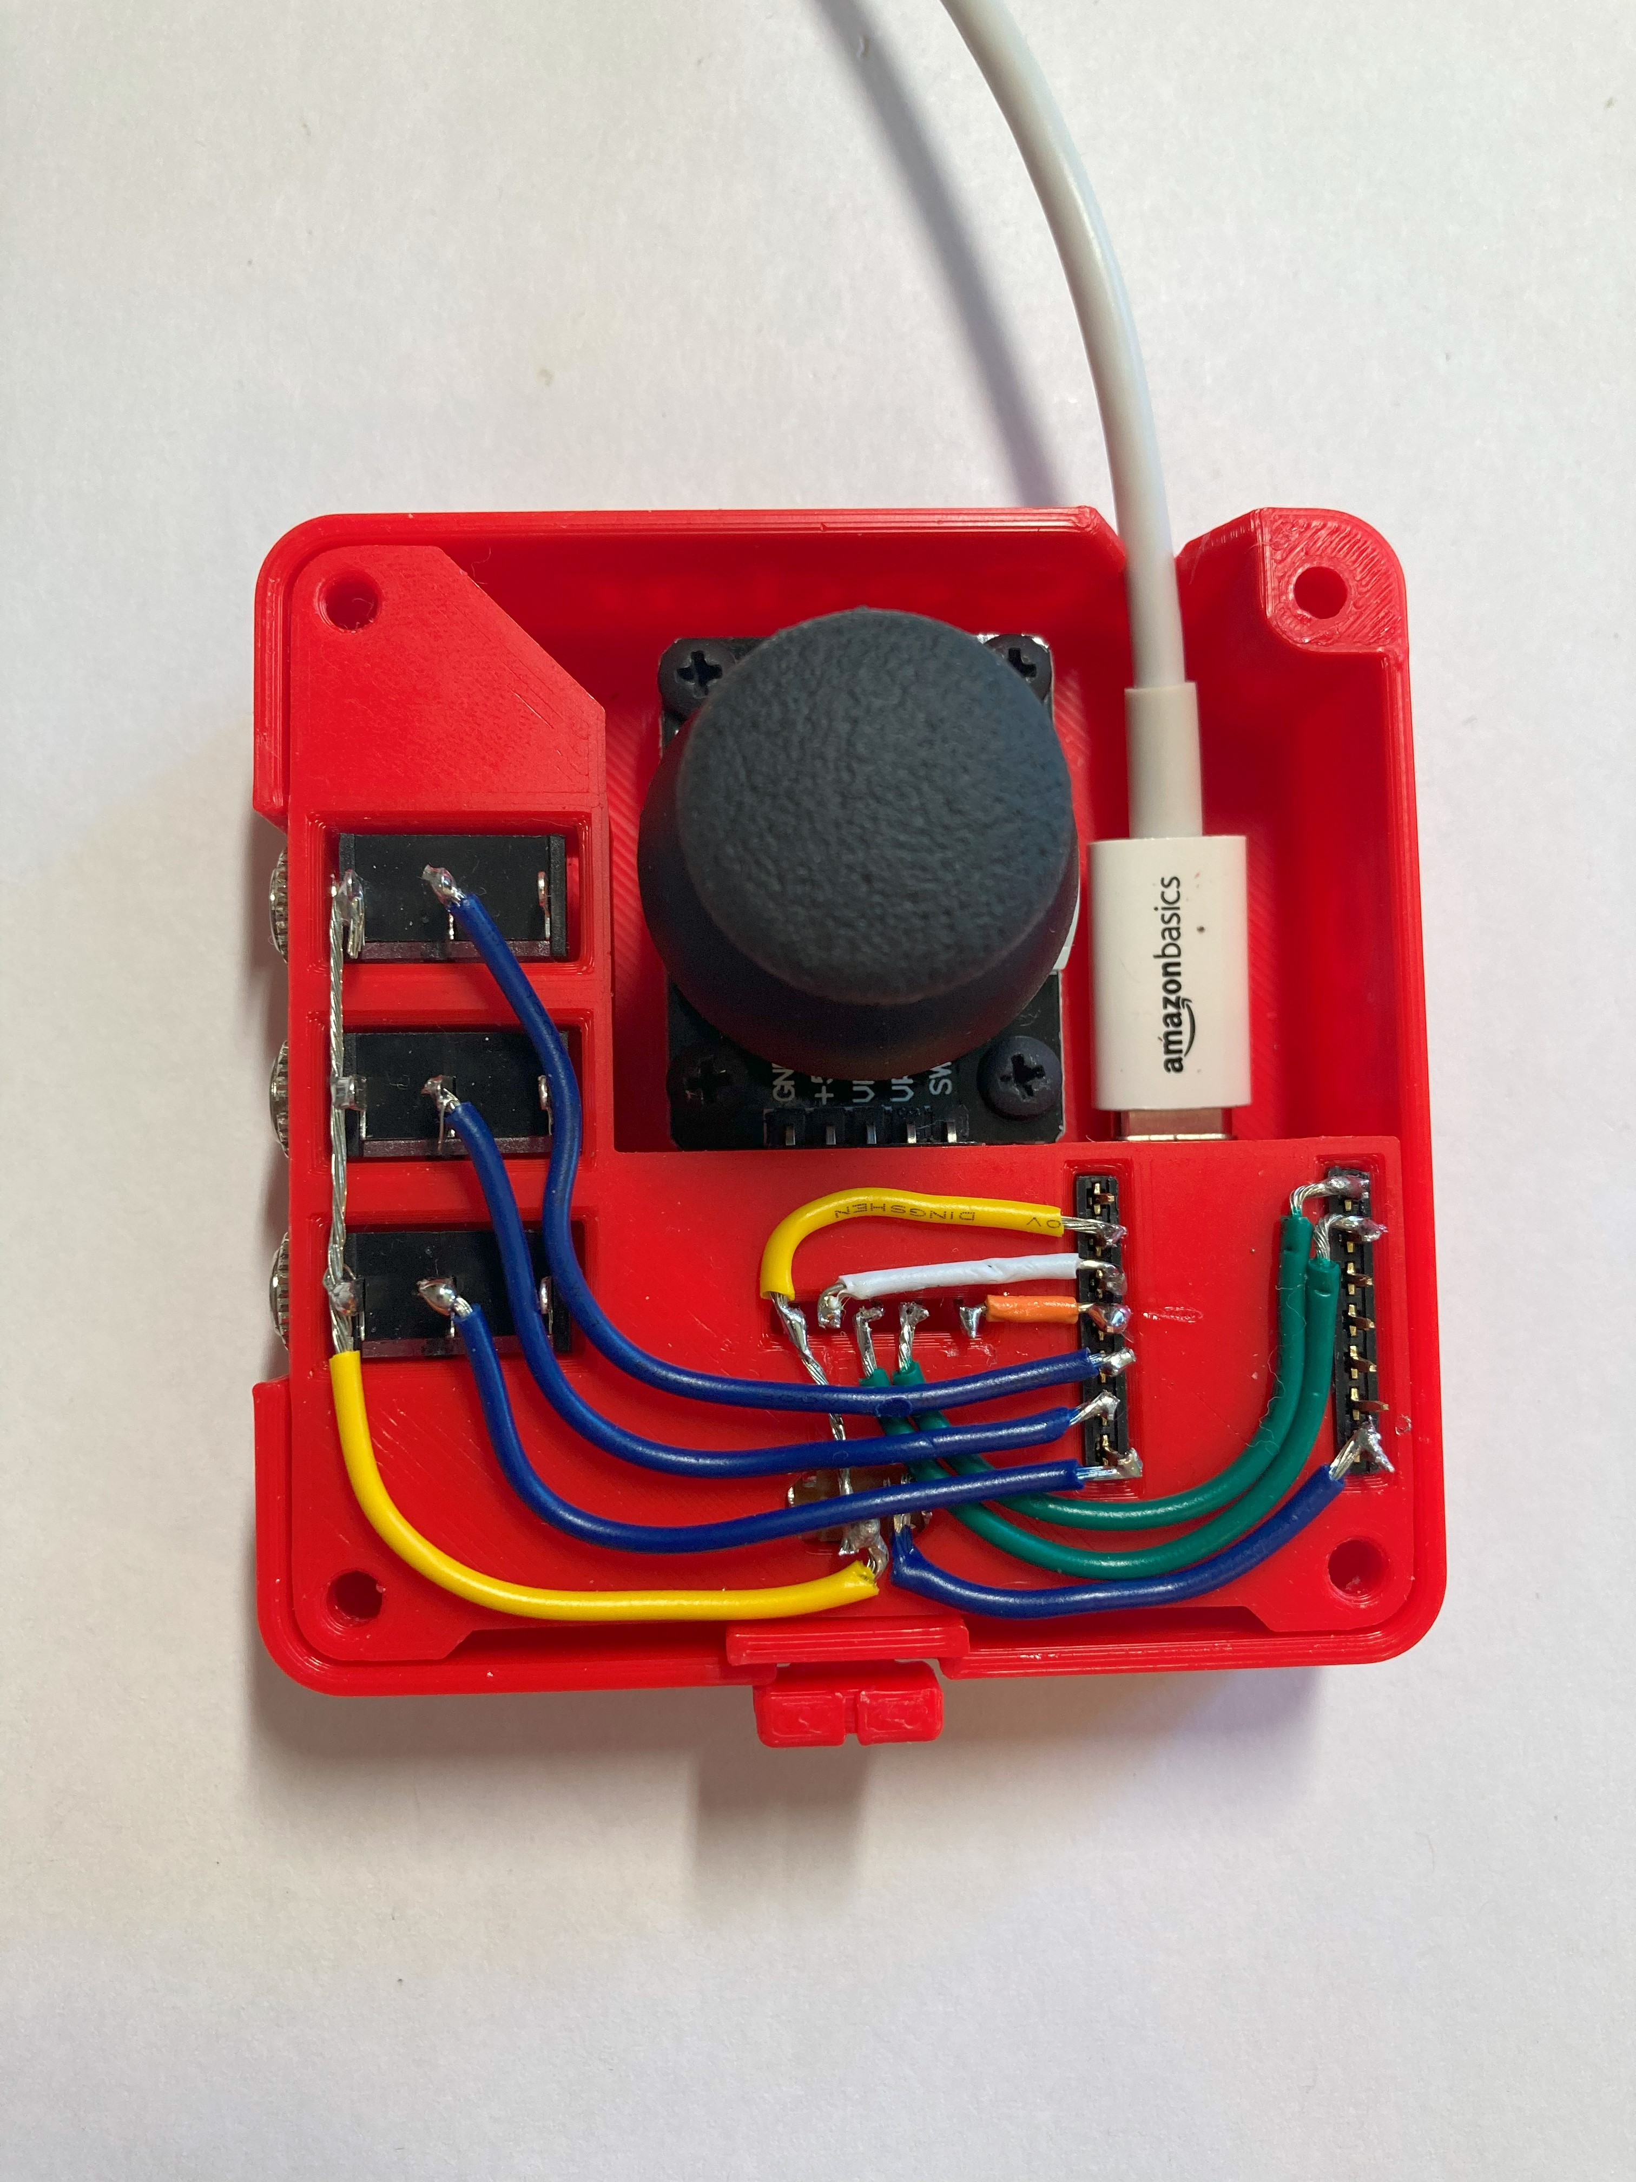

#### Enclosure Top

For the top of the enclosure, there is a hole for the joystick to go through, an arrow showing the ‘up” direction on the joystick, labels for the switch jacks, and alignment tabs for attaching the top and bottom together. There are also an insert for the cable hole, and four screw holes in the corners. The diameter of these screw holes is 2.68 mm for size 4 self threading sheet metal screws.

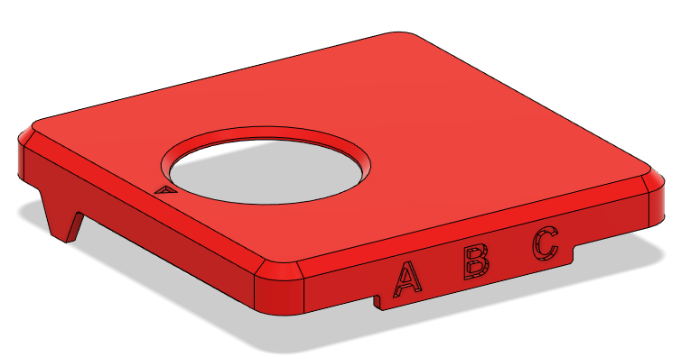

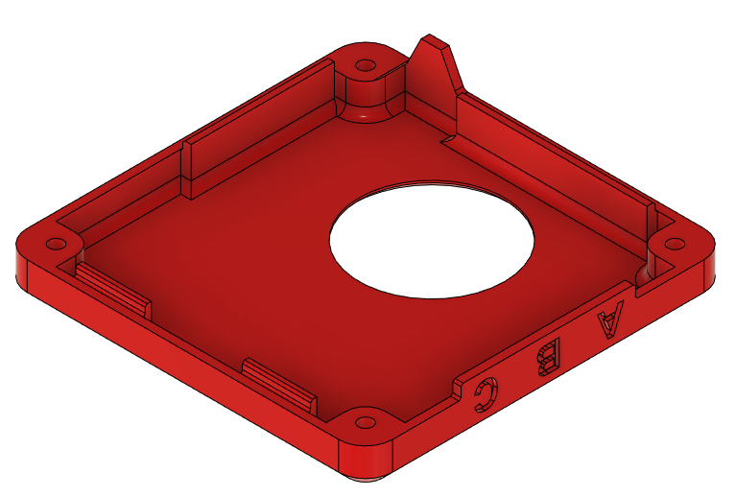

### Firmware Design

The overall function of the code is mentioned above, with mouse mode and joystick mode included in one firmware and the mode being set by a slide switch. The switch outputs of three switches and the joystick pressdown button are represented in the following table:

|  |  |  |  |  |
| --- | --- | --- | --- | --- |
| **Switch** | **Mouse** | **Joystick** | | |
| **PC** | **XAC (left)** | **XAC (right)** |
| A | Left click | Button 1 | X1 | View |
| B | Middle click (scroll) | Button 2 | X2 | Menu |
| C | Right click | Button 3 | Left stick (left press) | Right stick (right press) |
| Joystick push down | Left click | Button 4 | Left bumper | Right bumper |

There are also some variables at the start of the code that can be changed to customize the joystick functionality for the user, these include:

* Deadzone level (JOYSTICK_DEFAULT_DEADZONE_LEVEL)
* Mouse movement speed (MOUSE_MAX_XY)

## Testing

## Opportunities for Improvement (OFI)

* Add rounded corners to 3DP Circuit Board
* Reduce different types of fasteners
  + #4 self-tapping screws
  + M3 mounting screws
* Mounting interface fastener sizing
  + availability of sizes
* Mounting interface hole spacing
  + Is there a standard/common mounting hole spacing what could be used?
* Cable strain relief
* Mono jack mounting
  + Add material so it is not just reliant on the panel mount nut
    - Add some underneath to prevent it from going “through” 3D PCB
    - Maybe add snap fit when pushing the mono jack into place
* Gap between joystick topper and enclosure
  + Reduce this or add something between them so things don’t fall in
* Components:
  + Joystick unit in single quantity
  + Joystick unit supplier that is reliable and consistent product
* Wiring
  + Difficult to wire, requires precision and time
    - Consider a PCB for this? Especially for build events?
    - Consider wire channels, similar to Lynx?

Design choices to ask about during user testing, potential OFIs

* Placement of mono jacks, slide switch, and USB-C exit
* Position of joystick in enclosure, would users prefer it is centered front to back?